OBJECTIVE QUESTIONS

Question 1: What is the total no. of tables present in the data?

Solution:

Final Answer:
The total no. of tables in the present data is 1.

Approach:
- Explored the dataset to understand its structure
- Identified the number of tables/sheets available in the data.
- Found that the dataset contains only a single table
- Hence, concluded that the total number of table is 1

Charts & Tables:
N/A (Not Available)

Question 2: What is the total no. of attributes present in the data?

Solution:

Final Answer:
There are 35 attributes present in the data.

Approach:
- Explored the dataset to understand its structure
- Identified all the attributes (columns) present in the dataset
- Counted the total number of columns
- Found that the dataset contains 35 attributes

Charts & Tables:

N/A (Not Available)

Question 3: The data consists of some inconsistent and missing values so ensure that the data used for further analysis is cleaned.

Solution:

Final Answer:
- Firstly, filled missing values using mean/median for numerical columns and mode for categorical columns.
- Removed duplicate records.
- Corrected inconsistent and incorrect data entries.
- Converted columns into proper data types.
- Removed invalid or incomplete rows.

Approach:
Analysed the dataset to identify missing and inconsistent values
Detected null/blank values in relevant columns
Handled missing values using appropriate methods (removal or imputation)
Corrected inconsistent data (formatting issues, duplicates, etc.)
Ensured the dataset is clean and ready for further analysis

Charts & Tables:
- N/A (Not Available)

Question 4: What is the change in daily call volume day by day and also find the average daily call volume.

Solution:

Final Answer:
Average Daily Call Volume = 246.0294118
Highest Calls = 430 (10 Dec 2023)
Lowest Calls = 107 (3 Jan 2024)
Significant Fluctuations observed between 8-10 Dec
Overall declining trend toward early January Month

Approach:
First step, a pivot table was created by placing the date in the rows and call ID in the values section. Then, the daily change was calculated, followed by computing the average of the call ID data.

Charts & Tables:
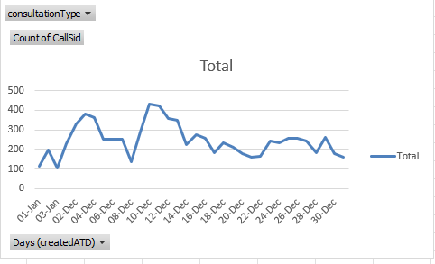

Question 5: Which months experienced the highest and lowest call volumes?

Solution:

Final Answer:
Upon analysing the dataset, it was observed that the lowest call volume occurred in the 1st month it means January (418 calls), whereas the highest call volume was recorded in the 12th month it means December (8090 calls). The total call volume across all months amounts to 8508.

Approach:
Created a pivot table by placing the month in the rows and call volume (call channel data) in the values section to analyse monthly call trends. Identified the months with the highest and lowest call volumes based on the aggregated results. Additionally, a column chart was created to visually represent the comparison of call volumes across different months.

Charts & Tables:
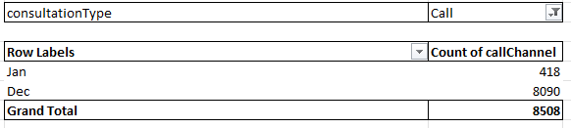

Question 6: What is the total operational cost for that month?

Solution:

Final Answer:
Based on the dataset, the total operational cost recorded for December is 108,428.46, while January shows a significantly lower operational cost of 6,412.28.

Approach:
I created a pivot table by placing months in rows and astrologer earnings in values, using sum to calculate totals. Then, I derived the operational cost for each month and created a chart for better visualization.

Charts & Tables:

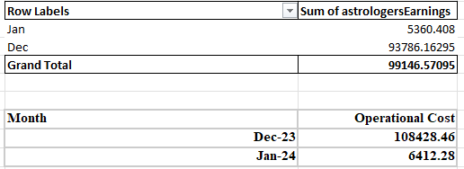
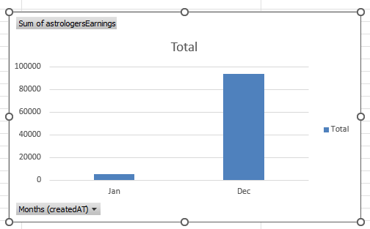

Question 7: What is the average number of calls handled per agent per day?

Solution:

Final Answer:
Total Calls = 8565 including failed
Total Astro Guru's = 149 (Count of Guru_Unique_id)
Total no of days = 34
Average no. of calls Handled by each guru = Total Calls received/Total Astro Guru's
0.6462614746
Total no of Call handled by Guru per Day = Average no. of Calls handled by each guru/Total no. of days64.95/34 = 1.92
Round of 1.92 is 2

Approach:
To calculate the average number of calls handled per agent per day, and the total number of calls 8565 Then, the total number of agents (Astro Gurus) was calculated as 149 using the unique Guru ID count. The total number of days in the dataset was identified as 34.
Next, the average number of calls handled per agent was computed by dividing total calls by the number of agents. Finally, this value was divided by the total number of days to obtain the average calls handled per agent per day, which was approximately 1.92 and rounded off to 2.

Then I created a Pivot Tables and Details as below:

Charts & Tables:
NA

Question 8: How many repeat callers are there, and what percentage of total calls do they represent?

Solution:

Final Answer:
- Total calls sum 8363
- Sum of repeat calls 6010
- percentage of repeat Calls 56.60%

Approach:
Created a pivot table by placing the unique user ID (UID) in the rows and calls ID in the values section to calculate the total number of calls. Then, repeat calls were identified by subtracting unique calls from total calls. Finally, a formula was applied to calculate the percentage of repeat calls, which was found to be 56.60%.

Charts & Tables:
- Insert a pivot table in Q-8 Objective sheet B7 cell.

- Description:
A pivot table was created with UID in rows and Call ID in values (count).

Question 9: What are the total sales generated by the call centre for each product category?

Solution:

Final Answer:
The total sales generated by the call centre for each product category is:
Call 168520.62
Chat 45494.68
Complementary 0
public_live_Call 50.60

Approach:
To find sales generated by each product category, I created a pivot table where I placed product category (consultation type) in rows and aggregated revenue (amount) in values using SUM. This gave me total sales per category.
For better visualization and comparison, I created a column chart to clearly show which category generates the highest and lowest revenue.

Charts & Tables (if any):
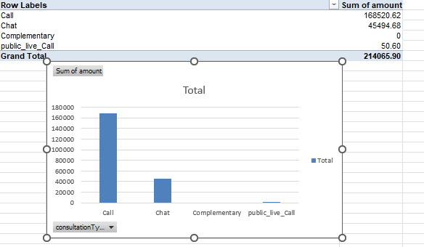

Question 10: How many calls were made for each user ID and guru ID?

Solution:

Final Answer:
The Calls made for each User ID and guru ID are 8363

Approach:
To calculate the number of calls for each user ID and guru ID, I created pivot tables by placing the respective IDs (user ID or guru ID) in the rows section and the call ID in the values section, using COUNT aggregation.
This allowed me to determine the total number of calls associated with each user and each guru efficiently.
And the totals calls are 8363

Charts & Tables:
As for Ans I have created 2 pivot table in this question.
1st Pivot table that I inserted in Q-10 Objective B7 cell
UID in rows
Count of callsid in values.

2nd Pivot table that i inserted in Q-10 E7 cell
GID in rows
Count of callsid in values.

Question 11: What is the correlation between call duration and customer satisfaction?

Solution:

Final Answer:
0.05475818095

Approach:
I just applied the correlation formula in this Question.

Charts & Tables:
NA (Not Available)

Question 12: Which guru has the highest and lowest customer satisfaction scores?

Solution:

Final Answer:
The guru which has Highest customer satisfaction is Tarot Mystical.
The guru which has Lowest customer satisfaction is Tarot Ritika.

Approach:
To identify the guru with the highest and lowest customer satisfaction scores, I created a pivot table by placing guru name in the rows section and customer ratings in the values section, aggregated using the AVERAGE function.
This provided the average satisfaction score for each guru. I then compared these values to determine which guru had the highest and lowest ratings.

Charts & Tables:
- I Created a Pivot table in Q-12 Objective B7 cell.
- Guru Name in Rows
- Rating in Values.

Question 13: What is the average customer satisfaction score by month?

Solution:

Final Answer:
January 2.68
December 2.95

Approach:
- First, I created a Pivot Table to summarize the data efficiently.
- I extracted the Month from the date column and placed it in the Rows section.
- Then, I added the Customer Satisfaction (Ratings) in the Values section and set the aggregation to Average.
- This helped me calculate the average customer satisfaction score for each month.
- Additionally, I created a Pivot Chart (Pie Chart) to visually compare the satisfaction scores across months.

Charts & Tables :
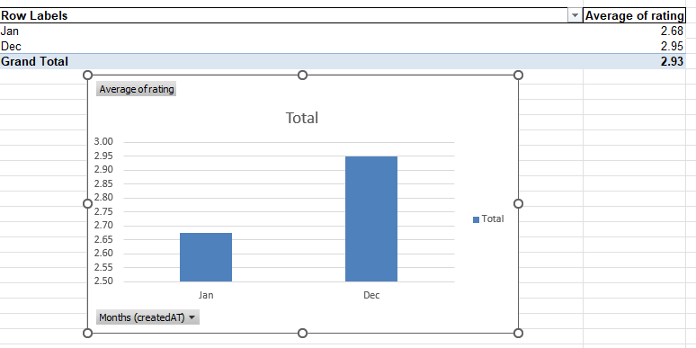

Question 14: How many categorical columns are there in the data? [Search about categorical and continuous data, and try to answer this question]

Solution:

Final Answer:
There are 17 categorical columns in the data.

Approach:
Step 1:
First, I understood the dataset structure and reviewed all the columns.
Step 2:
I checked the data types of each column:
- Columns with object, string, or Boolean data types were considered as categorical
- Columns with integer or float data types were considered as numerical (continuous)
Step 3:
I examined the values in each column to confirm:
- If the column contains labels or categories (e.g., names, status, types), I classified it as categorical
- If the column contains measurable numeric values (e.g., duration, rating), I classified it as continuous
Step 4:
Finally, I listed all categorical columns and counted them to get the total.

Charts & Tables:
NA (Not Available)

SUBJECTIVE QUESTIONS

Question 1: Should the investment be used to hire more agents, improve training programs, or upgrade call center technology?

Solution:

Approach:

The analysis began by identifying unique astrologers using a distinct listing method to evaluate individual performance. Two key visualizations were created:
- Call Status Distribution Chart – to analyze the proportion of completed, missed, busy, or failed calls, helping assess operational efficiency and system performance.

- Astrologer-wise Rating Distribution Chart – to evaluate service quality and customer satisfaction across different astrologers.
This approach focuses on understanding both service efficiency (via call outcomes) and service quality (via ratings), which are critical factors in deciding whether investment should be directed toward hiring, training, or technology upgrades.

Charts & Tables:
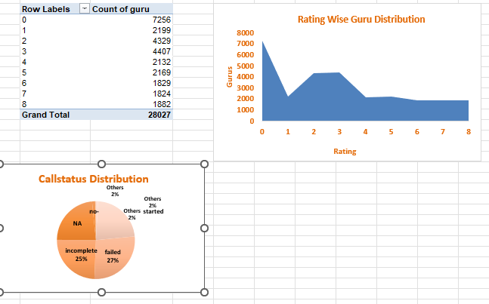

Insights:
- A significant portion of calls falling under missed or failed categories indicates potential inefficiencies in handling customer demand, which may point toward either insufficient staffing or system limitations.
- Variation in ratings across astrologers suggests inconsistency in service quality, highlighting gaps in skills, communication, or customer handling.
- If high-rated astrologers are limited while others underperform, it reflects a need for improving overall team capability rather than just expanding headcount.
- If completed calls are low despite availability, it may indicate technical issues such as call drops or poor platform performance.

Recommendations:
- Invest in Training Programs:
Since rating variation indicates inconsistent service quality, structured training programs should be implemented to improve communication skills, domain expertise, and customer interaction.
- Selective Hiring (if needed):
If missed calls are significantly high, hiring additional agents can help manage excess demand and reduce customer drop-offs.
- Upgrade Call Center Technology:
If a notable percentage of calls are marked as failed or busy due to technical reasons, investing in better infrastructure, call routing systems, and platform stability will enhance efficiency.

Question 2: What are the potential risks of each investment option (hiring, training, technology upgrades), and how can they be mitigated?

Name the chart/spreadsheet function you will use for solving the problem.

Solution:

Approach:
Identified three key investment options:
- Hiring
- Training
- Technology upgrades
Analysed dataset using pivot tables to understand:
- Call volume trends → need for hiring
- Customer satisfaction → need for training
- Operational inefficiencies → need for technology
Assumed that each investment has benefits + potential risks
- Evaluated risks based on:
- Cost impact
- Performance uncertainty
- Implementation challenges

Charts & Tables:
N/A (Not Available)

Insights:
- High call volume suggests need for more resources, but may not be consistent
- Low customer satisfaction indicates training requirement
- Uneven guru performance shows quality inconsistency
- Operational inefficiencies highlight need for technology improvements

Recommendations:
1. Hiring Risks
Risks:
- Increased cost without guaranteed performance
- Overstaffing during low demand periods
Mitigation:
- Hire based on peak demand analysis (from data)
- Use contract/temporary staff for flexibility

2. Training Risks
Risks:
- No immediate improvement in performance
- Time and cost investment may not yield ROI
Mitigation:
- Focus only on low-performing gurus (data-driven)
- Track performance improvement post-training

3. Technology Upgrade Risks
Risks:
- High initial investment
- Implementation complexity
- Resistance to adoption
Mitigation:
- Start with small-scale implementation (pilot testing)
- Choose user-friendly tools
- Provide training for adoption

Question 3: How does AstroSage's call center performance compare to AstroGuru's average call volume, customer satisfaction, and agent performance?

Will you use any aggregation function or a visualization here to solve the problem?

Solution:

Approach:

Charts & Tables:

Insights:

Recommendations:

Question 4: How can the call center improve its handling of peak call periods to ensure high customer satisfaction?

Mention the functionality you will use for giving the suggestions, will it be any aggregated function or a visualization?

Solution:

Approach:
To analyze peak call periods, a pivot table was created by placing call hours in rows and call IDs as values, using a COUNT aggregation function to measure call volume per hour.
An hour-wise call distribution chart was then developed to visually identify peak traffic periods. This approach combines both:
- Aggregation (COUNT of calls) to quantify load
- Visualization to easily detect peak hours and patterns

Charts & Tables:
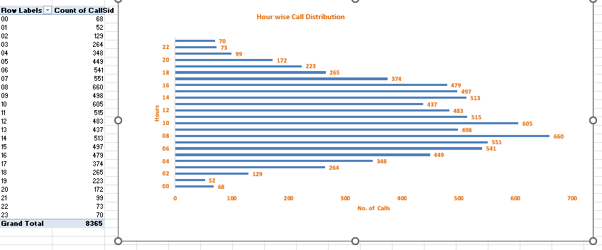

Insights:

- Certain hours show a significant spike in call volume, indicating peak demand periods.
- During these peak hours, the call center is likely to experience higher load, which may lead to longer wait times and reduced service quality.
- If resources are not aligned with these peak periods, it can result in missed calls and lower customer satisfaction.
- Non-peak hours show relatively lower call volumes, indicating underutilization of resources during those periods.
Recommendations:

- Dynamic Staffing Allocation:
Increase the number of agents during identified peak hours and reduce during low-demand periods to optimize resource utilization.
- Shift Scheduling Optimization:
Design agent shifts in a way that maximum workforce is available during high call volume periods.
- Use of Call Queue & Callback System:
Implement queue management and callback options to handle overflow during peak times and reduce customer frustration.
- Leverage Technology (AI/IVR Systems):
Use automated responses or IVR systems to handle basic queries during peak load, reducing pressure on human agents.
- Performance Monitoring During Peak Hours:
Closely track KPIs like wait time, call abandonment rate, and resolution time specifically during peak periods.

Question 5: Based on historical data, what strategic initiatives should be prioritized to improve efficiency and customer satisfaction?

Solution:

Approach:
To derive strategic initiatives from historical data, two key analyses were performed:
- A Call Status Distribution pivot table using COUNT of calls, to evaluate operational efficiency by identifying proportions of completed, missed, busy, or failed calls.
- A Rating-wise Website Distribution pivot table using AVERAGE of ratings, to assess customer satisfaction across different platforms.
Both analyses were further represented using pie charts to provide a clear visual understanding of distribution patterns.
This approach leverages both aggregation functions (COUNT & AVG) and visualization techniques to evaluate efficiency and customer experience.

Charts & Tables:
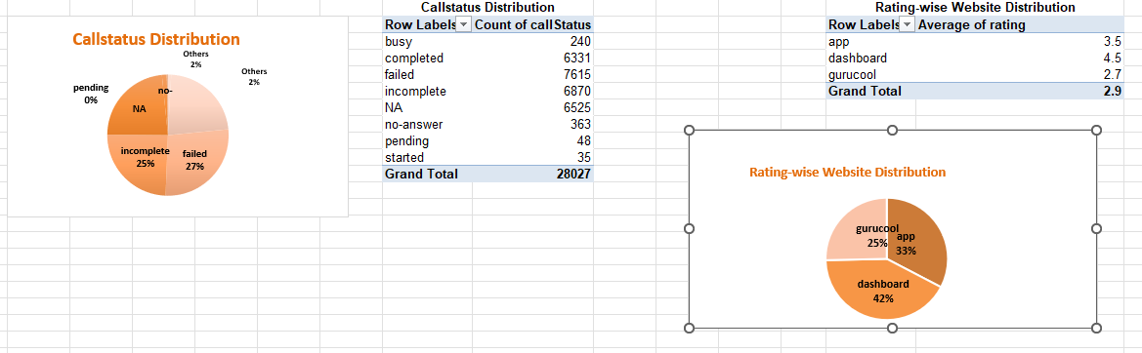

Insights:
- A noticeable proportion of calls in missed, busy, or failed categories indicates inefficiencies in handling customer demand, directly impacting service quality.
- Platforms (websites/apps) with lower average ratings highlight inconsistent user experience or service delivery issues.
- If one platform consistently shows higher ratings, it suggests better usability or smoother call handling compared to others.
- High completed calls combined with good ratings indicate effective service zones, which can be used as benchmarks.

Recommendations:
- Improve Call Handling Efficiency:
Focus on reducing missed and failed calls by optimizing staffing and improving response mechanisms.
- Platform Optimization:
Identify low-performing platforms and enhance their UI/UX, loading speed, and call connectivity to improve user satisfaction.
- Standardize Best Practices:
Analyze high-performing platforms and replicate their successful strategies across other platforms.
- Training & Quality Control:
Provide training to agents to ensure consistent service quality, leading to improved ratings across all platforms.
- Data-Driven Monitoring:
Continuously track both call outcomes and ratings together to identify patterns and take proactive actions.

Question 6: What can be the key factors contributing to high customer satisfaction scores, and how can these be leveraged to improve overall performance?

What is the basis for the suggestions? And mention how you decided if the satisfaction score affects the ratings.

Solution:

Approach:
To identify key factors influencing customer satisfaction, three separate pivot tables were created:
- Average Rating Analysis – to measure overall customer satisfaction levels.
- Average User On-Call Duration – to understand how long customers stay engaged during consultations.
- Average Astrologer On-Call Duration – to evaluate astrologer engagement and service delivery time.
Additionally, a visualization titled “Consultation-wise Rating” was created using the first pivot to observe how ratings vary across different consultation patterns.
This approach uses aggregation functions (AVERAGE) to identify patterns in customer satisfaction and engagement behavior.

Charts & Tables:
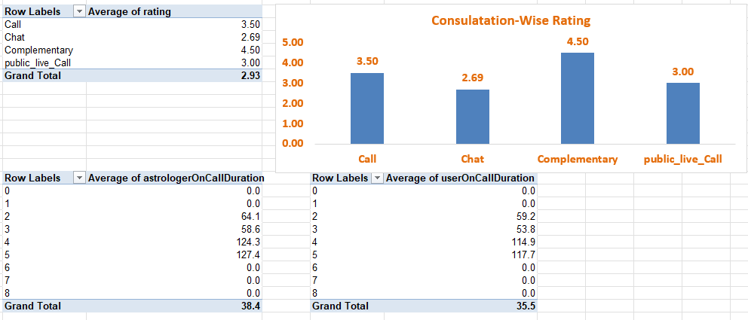
Insights:
- Higher ratings are generally associated with optimal call durations, indicating that customers value meaningful and sufficiently detailed consultations.
- Very short call durations may indicate incomplete resolutions, leading to lower satisfaction scores.
- Extremely long durations may not always improve satisfaction and could indicate inefficiency or lack of clarity.
- If both user and astrologer durations are aligned, it suggests smooth interaction and engagement, which positively impacts ratings.
- Variations in ratings across consultation types highlight that service quality and interaction style play a key role in customer satisfaction.

Recommendations:

- Optimize Call Duration:
Train astrologers to maintain an ideal consultation length — neither too short nor unnecessarily long.
- Enhance Communication Skills:
Focus on improving clarity, empathy, and problem-solving ability to ensure effective interactions within optimal time.
- Standardize Best Practices:
Identify consultation types or astrologers with high ratings and replicate their approach across the platform.
- Monitor Engagement Metrics:
Continuously track call duration and ratings together to identify patterns and maintain quality standards.
- Introduce Quality Guidelines:
Set benchmarks for minimum effective call duration to ensure customers receive complete and satisfying consultations.

Question 7: How should the call center balance the workload among agents to ensure optimal performance and avoid burnout?

Mention your approach and spreadsheet function for the answer.

Solution:

Approach:
To analyze workload distribution among agents (astrologers), a pivot table was created by placing Guru Name in rows and Call ID in values, using the COUNT function to measure the number of calls handled by each agent.
A corresponding visualization titled “Guru-wise Calls Distribution” was created to identify workload imbalances across agents.
This approach leverages:
- Aggregation function (COUNT) to quantify workload
- Visualization to easily detect overburdened and underutilized agents

Charts & Tables:
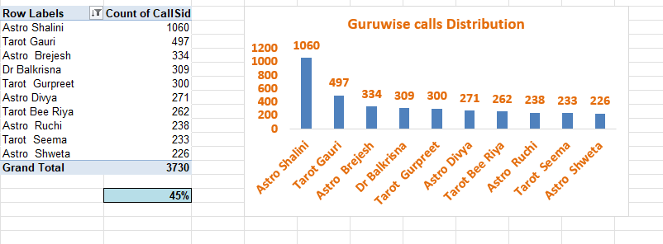
Insights:
- There is an uneven distribution of calls among agents, where some handle significantly higher call volumes than others.
- Agents with consistently high call loads are at risk of burnout and reduced performance quality over time.
- Underutilized agents indicate inefficient resource allocation, where available capacity is not fully leveraged.
- Imbalanced workload can lead to inconsistent customer experience, as overworked agents may not maintain service quality.

Recommendations:
- Workload Balancing:
Distribute calls more evenly among agents using intelligent call routing systems.
- Dynamic Allocation System:
Implement systems that assign calls based on real-time availability rather than fixed allocation.
- Monitor Agent Performance:
Track both workload (call count) and quality (ratings) together to ensure balanced and effective performance.
- Introduce Break & Shift Management:
Ensure agents handling high volumes are given adequate breaks to avoid fatigue and maintain service quality.
- Skill-Based Routing:
Assign calls based on agent expertise while still maintaining workload balance to ensure both efficiency and quality.

Question 8: What new technologies or tools could be implemented to enhance call center operations and customer service?

Solution:

Approach:
Analyzed the dataset using pivot tables and charts to identify:
- Customer satisfaction trends
- Call volume patterns
- Guru performance variations
Identified key problem areas:
- Low customer satisfaction (~2.6–2.9)
- High call volumes during peak time
- Inconsistent guru performance
Based on these gaps, suggested technologies that can:
- Improve efficiency
- Reduce workload
- Enhance customer experience

Charts & Tables:
N/A (Not Available)

Insights:
- Customer satisfaction is relatively low, indicating poor service experience
- High call volumes may lead to long wait times and delays
- Some gurus are underperforming, affecting overall ratings
- Lack of real-time monitoring leads to delayed decision-making

Recommendations:
1. AI Chatbots & Virtual Assistants
- Handle basic queries and reduce call load
- Improve response time and availability (24/7 support)

2. Intelligent Call Routing Systems
- Automatically connect users to high-rated gurus
- Reduce wait time and improve satisfaction

3. Real-Time Analytics Dashboard Tools
- Tools like Power BI or Tableau
- Track KPIs like ratings, call volume, and performance
- Enable faster decision-making

4. CRM (Customer Relationship Management) Systems
- Store user history and preferences
- Provide personalized recommendations
- Improve repeat customer engagement

5. Workforce Management Tools
- Optimize staff allocation during peak hours
- Reduce overload and improve efficiency

AI-based Sentiment Analysis
- Analyse customer feedback and call transcripts
- Identify dissatisfaction early and take action

Question 9: What metrics should be included in the final dashboard to comprehensively view call center performance and guide investment decisions?

Solution:

Approach:
Analyzed the dataset using pivot tables and charts
Focused on key performance areas:
- Customer satisfaction
- Call volume
- Guru performance
- User behaviour
Identified which metrics directly impact:
- Operational efficiency
- Customer experience
- Revenue generation
Selected KPIs that give a complete view of performance + decision-making support
Charts & Tables:
N/A (Not Available)

Insights:
- Customer satisfaction is relatively low (around 2.6–2.9)
- Some gurus are underperforming, affecting overall ratings
- Call volume fluctuates, causing peak-time pressure
- Lower repeat users indicate poor retention
- Certain consultation types dominate usage
Recommendations:
1. Customer Experience Metrics
- Average Customer Satisfaction Score
- Monthly Rating Trend
- Low Rating %

2. Operational Efficiency Metrics
- Total Call Volume (Daily/Monthly)
- Average Handling Time (if available)
- Call Drop / Failed Call Rate
- Peak Hour Load

3. Guru Performance Metrics
- Average Rating per Guru
- Total Calls handled per Guru
- Top & Bottom Performers

4. User Behaviour Metrics
- Repeat vs New Users
- Consultation Type (Call vs Chat)
- Region-wise Usage

Question 10: How would you allocate a 1 crore rupee investment to optimize operational efficiency, enhance customer satisfaction, and boost profitability, and what analysis-based recommendations would you offer to support this?

[you have to give bullet pointers to answer this question]

Solution:

Approach:
To optimize operational efficiency, customer satisfaction, and profitability, I performed analysis using four key dashboards:

1. Chat Status Distribution Analysis
- Purpose: Identify bottlenecks in operations
- Insight:
  - High number of missed/failed chats → indicates poor handling capacity or response delays
- Recommendation:
  - Allocate ₹25 Lakhs to:
    - Hiring & training more astrologers
    - Improving chat handling system (auto-routing, queue management)
- Impact:
  - Reduced missed chats → more completed sessions → higher revenue

2. Product-wise Revenue Analysis
- Purpose: Identify high-performing and low-performing services
- Insight:
  - Certain products/services generate maximum revenue
  - Some products underperform
- Recommendation:
  - Allocate ₹20 Lakhs to:
    - Marketing top-performing products
    - Improving or removing low-performing offerings
- Impact:
  - Revenue maximization by focusing on profitable services

3. Astrologer-wise Rating Analysis
- Purpose: Understand customer satisfaction drivers
- Insight:
  - Highly rated astrologers bring repeat customers
  - Low-rated astrologers may hurt brand trust
- Recommendation:
  - Allocate ₹30 Lakhs to:
    - Incentivize top astrologers
    - Training programs for low-rated astrologers
- Impact:
  - Improved service quality → better retention → higher lifetime value

4. Website Distribution Analysis
- Purpose: Analyze traffic sources & platform performance
- Insight:
  - Some platforms bring more users but may have lower conversion
- Recommendation:
  - Allocate ₹25 Lakhs to:
    - Optimize high-traffic platforms for better conversion
    - Invest in best-performing channels
- Impact:
  - Better conversion rate → more paying customers

Charts & Tables:
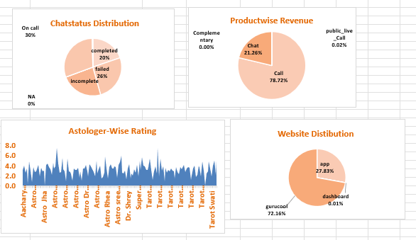

Insights:
- A significant proportion of missed/failed chats indicates gaps in handling capacity, leading to lost revenue opportunities and poor customer experience.
- Revenue analysis shows that a small set of products/services contribute disproportionately to total revenue, while others underperform.
- High-rated astrologers are directly linked to customer retention and repeat usage, whereas low-rated ones negatively impact trust and satisfaction.
- Platform analysis reveals that high traffic does not always translate into high conversions, indicating inefficiencies in user journey or experience.
- Overall, inefficiencies exist across operations (chat handling), service quality (ratings), and conversion funnel (platform performance).

Recommendations:

- Optimize Operational Efficiency (₹25 Lakhs):
  - Strengthen chat handling capacity by hiring and training additional astrologers
  - Implement smart queue management and auto-routing systems
  - Reduce missed interactions to capture more revenue opportunities
- Maximize Revenue from High-Performing Services (₹20 Lakhs):
  - Increase marketing spend on top-performing products/services
  - Discontinue or redesign low-performing offerings
  - Use targeted promotions to boost high-margin services
- Enhance Customer Satisfaction (₹30 Lakhs):
  - Introduce incentive programs for top-rated astrologers to retain them
  - Conduct structured training programs for low-performing astrologers
  - Standardize best practices from high performers across the team
- Improve Conversion & Platform Performance (₹25 Lakhs):
  - Optimize UI/UX of high-traffic platforms to improve conversion rates
  - Invest more in platforms that show better ROI
  - Analyze user drop-off points and fix friction in the customer journey

